

**Strewnify Compiled**

**Meteor Event Database**

Specification Document

Contact: Jim Goodall

Email: [james.a.goodall@gmail.com](mailto:james.a.goodall@gmail.com)

Phone: +1 586 709 5888

Created: February 18, 2020

Last Updated: March 23, 2023

# Introduction

## Database Overview

The Strewnify Compiled Meteor Event Database (SCMED) is database of meteor fireball events, compiled from multiple sources, for the purpose of research and meteorite recovery. The database format was first developed by Jim Goodall, in 2020, in the MATLAB computing environment. It is the intent of the developer that this database will be a publicly available resource, useful for all types of meteor research. Although individual meteorite find data can be stored in this database, it is important to note that SCMED was developed to store meteor event data, and was not intended as a meteorite database.

## Data Import

TBD

## Contributing Data

TBD

## Data Quality

All data in SCMED is required to include metadata, which indicates the source and quality of the data.

TBD

# Database Structure

## Meteor Event Data Hierarchy

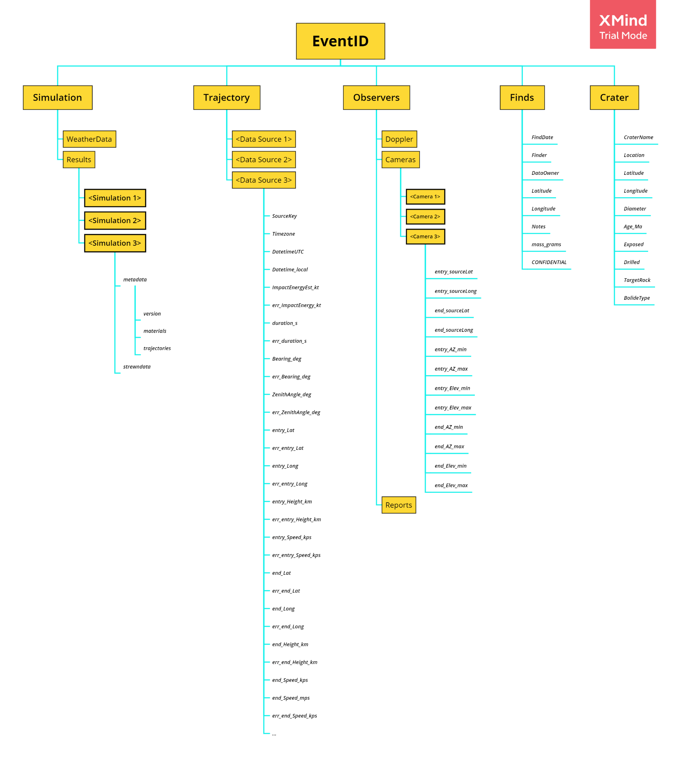Data in the database is arranged in the following structure.

## Handling Duplicates and Uncertainty

External Database Example Key Mapping

3 similar events from source, confirmed to be 3 separate events

2 events from source, determined to be 1 event

|  |  |
| --- | --- |
| SourceKey (foreign key) | EventID (primary key) |
| … | … |
| ‘608abe2c974c8c2a6e2d01c0’ | ‘Y20200420_15Z_18P’ |
| ‘60992f33ed1b3b23ac9cdcda’ | ‘Y20200420_15Z_18P’ |
| ‘60992f33ed1b3b23ac9ce297’ | ‘Y20220104_18Z_17T’ |
| ‘60992f33ed1b3b23ac9ce300’ | ‘Y20220104_181_17T’ |
| ‘60992f33ed1b3b23ac9ce302’ | ‘Y20220104_182_17T’ |
| … | … |

There are three types of duplicate event scenarios that must be handled by the database:

* + 1. Merge Events from Source(s)

It is possible that multiple EventID’s could be incorrect assigned to the same event, if the event occurs on the hour or near a MGRS Grid Zone boundary. For example, for an event that occurred very near to 2:00 in Columbus, Ohio, USA, might be assigned any of the following EventID’s:

20220201_01Z_17T

20220201_01Z_17S

20220201_02Z_17T

20220201_02Z_17S

If multiple events occur in the same hour, in the same MGRS Grid Zone, they would be separated as unique events by the duplicate event identifier, as described in the Event Identifier section. The SourceKey (foreign key) field shall be used to map the duplicate events to the correct EventID.

If a source identifies two events, or the same event is recorded by multiple sources and more than one nominal EventID is generated, but analysis concludes they are the same event, foreign key mapping will be used to prevent primary keys from being generated in the future. The process of mapping keys could be automatic in many cases, but sometimes manual mapping will be required. The following criteria is recommended to identify separate events:

* Nominal location (LAT/LONG) > 400 km from duplicate event
* Nominal entry time (Datetime) > 20 minutes different from duplicate event

Duplicate mapping shall be stored in the database, and organized by source. An example duplicate mapping table is shown in Table 1.5.

* + 1. Split Events

If a source incorrectly merges two events, the data will be invalid and shall be indicated in the database by TBD. Ideally, the information should be communicated to the database owner and corrected at the source, but this is not always possible

TBD…

## Event Identifier (EventID)

All event records in the database are first assigned an Event ID, which is a unique alphanumeric identifier, specific to that meteor event, and it acts as the database primary key. Typically, these record identifiers are automatically generated by an algorithm, but there is occasionally a need to generate or modify them manually. The sections below define the rules, which are used to generate the Event ID. The rules differ, depending on whether the event was witnessed or not.

**Example Event ID – Witnessed Event:**

Y20180117_01Z_17T

**Grid Zone Designator**

MGRS Grid Zone for the reference coordinates (lat/long)

**Hour Code**

HH

**Date Code**

YYYYMMDD

**Event Prefix**

Y = Witnessed

N = Unwitnessed

**Duplicate Index**

Z or

index

**Example Event ID – Unwitnessed Event**

N1920HOBA_M01_33K

**Event Evidence**

C = Impact Crater

M = Meteorite Find

T = Tektite Find

**Event Prefix**

Y = Witnessed

N = Unwitnessed

**Duplicate Index**

Increment up, from 1

**Event Name**

Official name, if available, first 4 letters

**Discovery Year**

YYYY

**Grid Zone Designator**

MGRS Grid Zone for the reference coordinates (lat/long)

## Event Category Prefix

The first digit of the EventID is the Event Prefix, which indicates the type of event, as shown in table below:

|  |  |  |
| --- | --- | --- |
| **Prefix** | **Category** | **Event Category Description** |
| Y | Witnessed | A meteor event that was witnessed by humans or sensors. In meteorite terminology, fragments recovered from a witnessed event are called “falls”. |
| N | Unwitnessed | A meteor event that was not witnessed. In meteorite terminology, fragments recovered from an unwitnessed event are called “finds”. |

## Date Code (Witnessed Events Only)

The date code stores the UTC date of the meteor event, in “YYYYMMDD” format. For example, an event occurring on July 4th, 1976, would have the date code “19760704”. Be careful to correctly adjust the local date and time zone to standard UTC date and time.

## Discovery Year (Unwitnessed Events Only)

The year the event was first discovered, in “YYYY” format. For example, this could be the date of the first meteorite recovery. Choose the **earliest** date from the following list:

* + - 1. The date the first meteorite or tektite was recovered, if known
      2. The date the first meteorite or tektite was identified
      3. The date of impact crater discovery
      4. The date of the first written record of the event

## Event Name Code (Unwitnessed Events Only)

All unwitnessed events must be assigned a name, and the name code is simply the first 4 alphabetic characters of that name, in ALL CAPS, with no spaces, and no diacritics. If an event name is shorter than 4 characters, the remaining characters shall be filled with the letter “X”. The name shall be assigned, according to the first applicable rule found in the prioritized list below.

Allowed naming strategies, in arbitration order:

* + - 1. Official find name from the Meteoritical Society bulletin
      2. Official Impact Crater name
      3. Commonly accepted unofficial name
      4. The name of the nearest settlement or natural feature

## Hour Code

The hour code stores the truncated UTC time of the meteor event, in “HH” format. For example, a meteor entering the atmosphere at 13:30 UTC, would have the hour code “13”. Be careful to correctly adjust the local date and time zone to standard UTC date and time.

When a meteor event occurs, the exact time of the event is not always known with precision. It is important to note that the Hour Code will be procedurally generated from the first source to report the event and it may be incorrect, if the event occurred near the beginning or end of the hour. To prevent duplicate records and database corruption, the algorithm will not attempt to update the EventID automatically. If corrections are needed, a database administrator will manually adjust the hour code, once the entry time of the meteor is known with certainty.

## Duplicate Event Index

* + 1. Duplicate Event Index - Witnessed Events

The digit following the hour code is reserved to document (rare) separate events, occurring in the same MGRS grid zone, in the same hour. These “duplicate events” would otherwise appear to have the same EventID, which would not be useful or acceptable. For readability, when it is not used, the digit is filled with the letter “Z”, for Zulu.

Since the EventID is used to algorithmically determine unique events, manual processing will be needed in the rare instance that multiple meteor fireballs occur in the same area in the same hour. In that scenario, the reserve digit will be incremented manually by a database administrator, as follows:

Example Duplicate Event Indices, in a multiple fireball scenario:

Event 1: Y20180117_01**Z**_17T Normal identifier, “Z” filler digit (abbrev. for for Zulu)

Event 2: Y20180117_01**1**_17T 1st “duplicate” event, indexed as 1

Event 3: Y20180117_01**2**_17T 2nd “duplicate” event, indexed as 2

Event 4: Y20180117_01**3**_17T 3rd “duplicate” event, indexed as 3

… …

Event 10: Y20180117_01**9**_17T

Event 11: Y20180117_01**A**_17T

Event 12: Y20180117_01**B**_17T

Event 13: Y20180117_01**C**_17T

…

Event 34: Y20180117_01**X**_17T

Event 35: Y20180117_01**Y**_17T

Event 36: NOT SUPPORTED

Up to 35 separate fireball events can be stored in this manner. As meteor fireballs are rare, this system should be sufficient to support all scenarios, short of encountering an unforeseen dense asteroid field! As of yet, no more than 2 events have been recorded in a single hour for a single MGRS grid zone.

* + 1. Duplicate Event Index - Unwitnessed Events

An incremental index assigned to each unwitnessed event, sharing the same first 9 digits.

For example, TBD.

## Event Evidence Type (Unwitnessed Events Only)

The Event Evidence Code indicates the type of evidence used to determine that a meteor event occurred, as found in Table. If multiple types of evidence exist for the event, the first applicable rule found, in the Table, shall be used. For example, if an impact crater exists and some tektites are documented to be linked to the event that forded the crater, then the type would be “C”, because craters are higher priority in the evidence list.

**Table. Event Evidence Type**

|  |  |  |  |
| --- | --- | --- | --- |
| **Type** | **Type of Evidence** | **Notes** | **Priority** |
| C | Impact Crater | An impact crater has been documented for this event. | 1 |
| M | Meteorite Find | Meteorites have been found for this event. | 2 |
| T | Tektite Find | Tektites have been found for this event. | 3 |

## MGRS Grid Zone Designator

The last section of the EventID contains a three-character representation of the Military Grid Reference System (MGRS) Grid Zone Designator (GZD) associated with the **Nominal Location** (Refer to Section XX for definition). GZD’s with less than three digits should be preceded by zeroes to complete the 3-digit requirement.

Table. Example Grid Zone Designators

|  |  |  |
| --- | --- | --- |
| **Location** | **Coordinates** | **GZD** |
| New York City | 40.661°N, 73.944°W | 18T |
| Honolulu, Hawaii | 21.307°N, 157.858°W | 04Q |
| Mount Kirkpatrick, Antarctica | 84.333°S, 166.417°E | 00B |

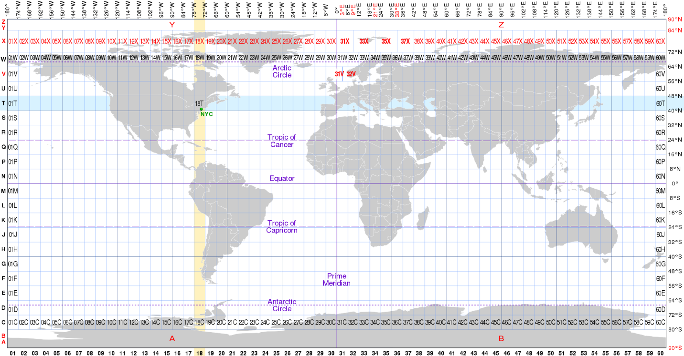

## Common Data Fields

### Datetime

UTC date and time of atmospheric entry

### Timezone

local time zone

### entry_Lat

Geometric trajectory latitude at entry

### entry_Long

Geometric trajectory longitude at entry

### entry_Altitude_km

Geometric trajectory altitude at first visible light

### entry_Speed_kps

Meteor speed at entry

### LAT

Geometric trajectory Latitude at 40km altitude. If the meteor does not reach 40km, the database shall indicate the location of minimum observed altitude. For example, the nominal location of an “earthgrazer” would be the point of tangency.

### LONG

Geometric trajectory Latitude at 40km altitude. If the meteor does not reach 40km, the database shall indicate the location of minimum observed altitude. For example, the nominal location of an “earthgrazer” would be the point of tangency.

### end_Lat

Geometric trajectory latitude at last visible light

### end_Long

Geometric trajectory longtude at last visible light

### impact_Lat

Geometric impact latitude

### impact_Long

Geometric impact longitude

### Location

reverse geocode of LAT/LONG from Google API

### Reference Point Description - ref_Description

A description of the reference point, typically one of the values defined in the Table.

Table. Reference Description

|  |  |
| --- | --- |
| **Ref_Description** | **Reference Point Type** |
| End | Some point, at or near the beginning of dark flight, where visible ablation ends. |
| Peak Intensity | The peak intensity point of the light curve. |
| First Peak | The first major peak in the light curve (in time), for events with multiple peaks. |
| Second Peak | The second major peak in the light curve (in time), for events with multiple peaks. |

### ref_Lat

reference point latitude

### ref_Long

reference point longitude

### ref_altitude_km

reference point altitude

### ImpactEnergyEst_kt

Estimated event impact energy, in kilotons of TNT

### ref_Bearing_deg

Meteor direction of travel, in degrees

### ref_ZenithAngle_deg

Slope of the meteor, measured in degrees from zenith

### ref_ElevationAngle_deg

Slope of the meteor, measured in degrees from horizon

### HyperMap

hyperlink to Google map location

### Hyperlink1

Primary link to source

### Hyperlink2

Secondary link to source

### DateProcessed

date the event was processed by the source

### DateAdded

date the event was added to the current database

### DateUpdated

date of last update to the current record

### SourceKey

This is a unique source database identifier (foreign key) for the event, used to map duplicate events to EventID (primary key). This identifier must be unique to the event, in the source database. Some sources do not have event identifiers, so a method of assigning source keys is necessary when adding new sources.

### source_record

This is the record index for sources that store multiple copies of the same event. The latest record in the import is marked as record 1, and older records are marked incrementally. Only the latest record will be compared to the latest matching source key in the database for import. If data has changed and no ProcessDate is available for compare, all records are imported as new records (rather than trying to match data to existing records in the database).

## Other Data Fields

### ref_speed_mps

reference point speed

### RadiatedEnergy_J

radiated energy measurement

### ImpactEnergy_kt

impact energy measurement, in kilotons

### ref_vx_ECEF_kps

ECEF x-component of velocity

### ref_vy_ECEF_kps

ECEF y-component of velocity

### ref_vz_ECEF_kps

ECEF z-component of velocity

### ref_vNorth_kps

NED north component of velocity

### ref_vEast_kps

NED east component of velocity

### ref_vDown_kps

NED down component of velocity

### EventName

Event name for library lookup

### Locality

nearest town to the strewn field or endpoint

### State

State or province

### Country

Country

## ImportUTC

## timezone

## ImportLocalTime

## nom_mass

## nom_speed

## nom_energy

## nom_bearing

## nom_angle

## ReferenceDescription

## nom_lat

## nom_long

## ref_elevation

## geometric_elevation

## ref_speed

## ref_slope

## darkflight_elevation

## material_sim

## material_class

## meas_density

## startaltitude

## fragaltitude

## error_speed

## error_bearing

## error_angle

## error_lat

## error_long

## error_elevation

## weather_minsigma

## weather_maxsigma

## find_strewnarea

## find_count

## find_masstotal_kg

## find_mainmass_g

## find_medianmass_g

## find_avgmass_g

## find_density

## source_CRE_Age

## source_general

## source_class

## source_density

## source_CRE_age

## source_energy

## source_trajectory_1

## source_trajectory_2

## source_trajectory_3

## source_trajectory_4

## trajectory_quality

## notes_strewnoffset

## notes_refz